**Research continued**

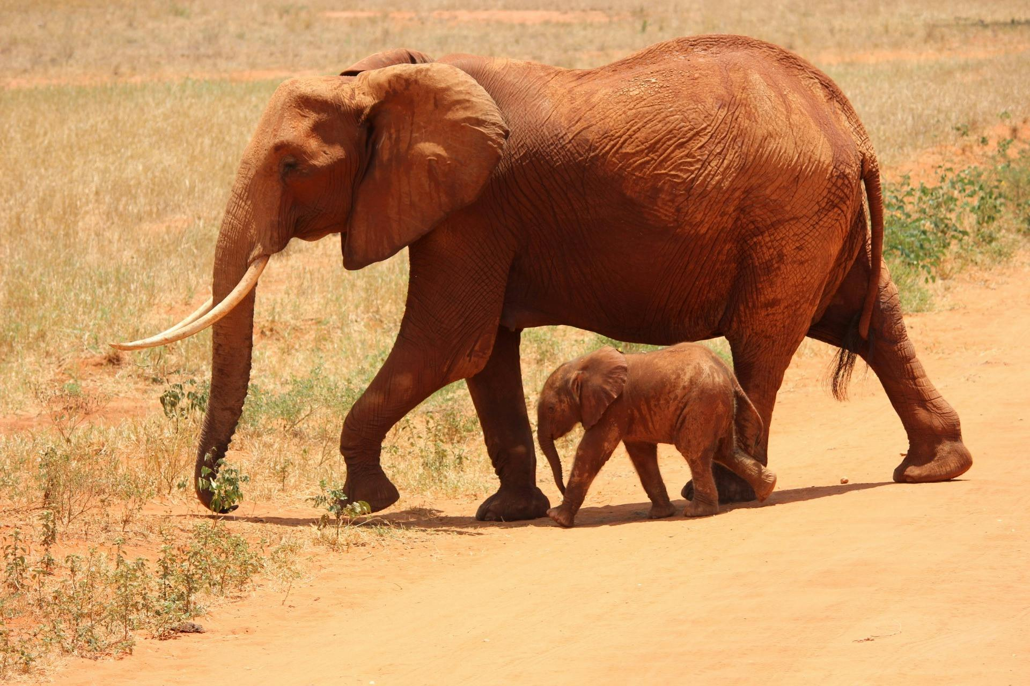

[1 Elephant Beside on Baby Elephant · Free Stock Photo (pexels.com)](https://www.pexels.com/photo/1-elephant-beside-on-baby-elephant-66898/)

[Public Domain - Creative Commons](https://creativecommons.org/public-domain/)

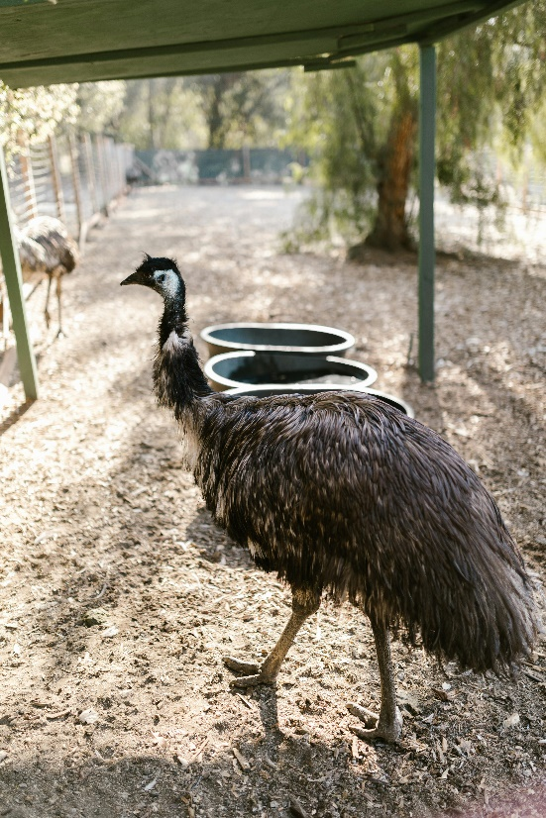

[Photo of an Emu · Free Stock Photo (pexels.com)](https://www.pexels.com/photo/photo-of-an-emu-7781980/)

[Public Domain - Creative Commons](https://creativecommons.org/public-domain/)

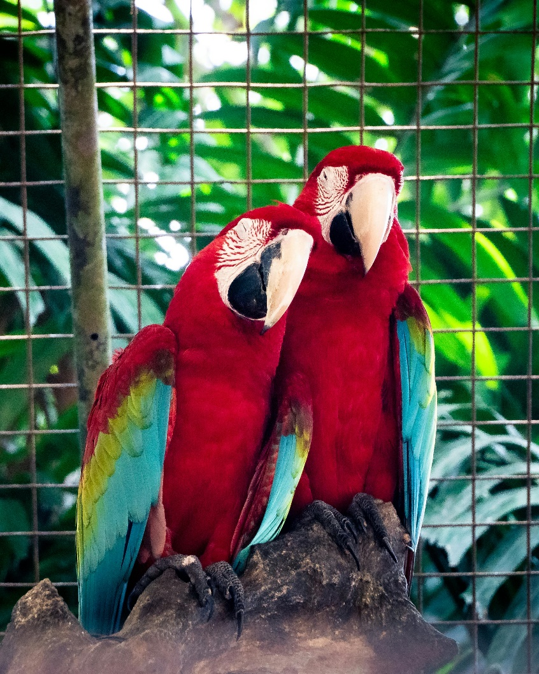

[A Romantic Macaw Couple · Free Stock Photo (pexels.com)](https://www.pexels.com/photo/a-romantic-macaw-couple-11903481/)

[Public Domain - Creative Commons](https://creativecommons.org/public-domain/)

Facilities

* Restaurants

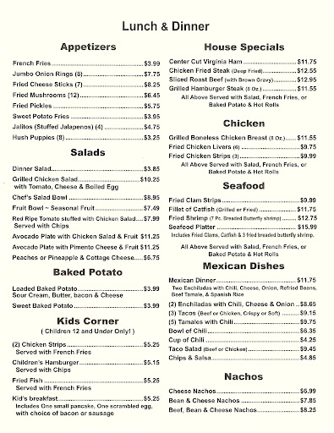

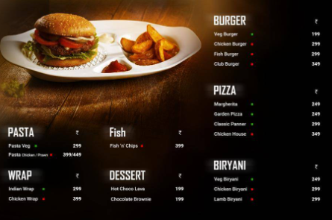

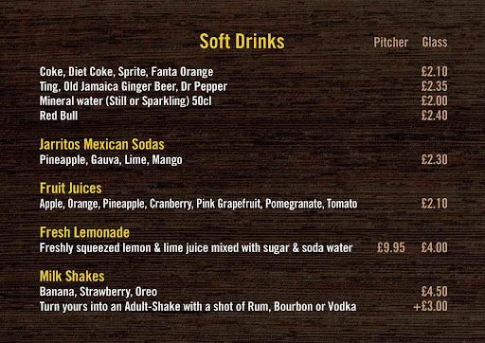

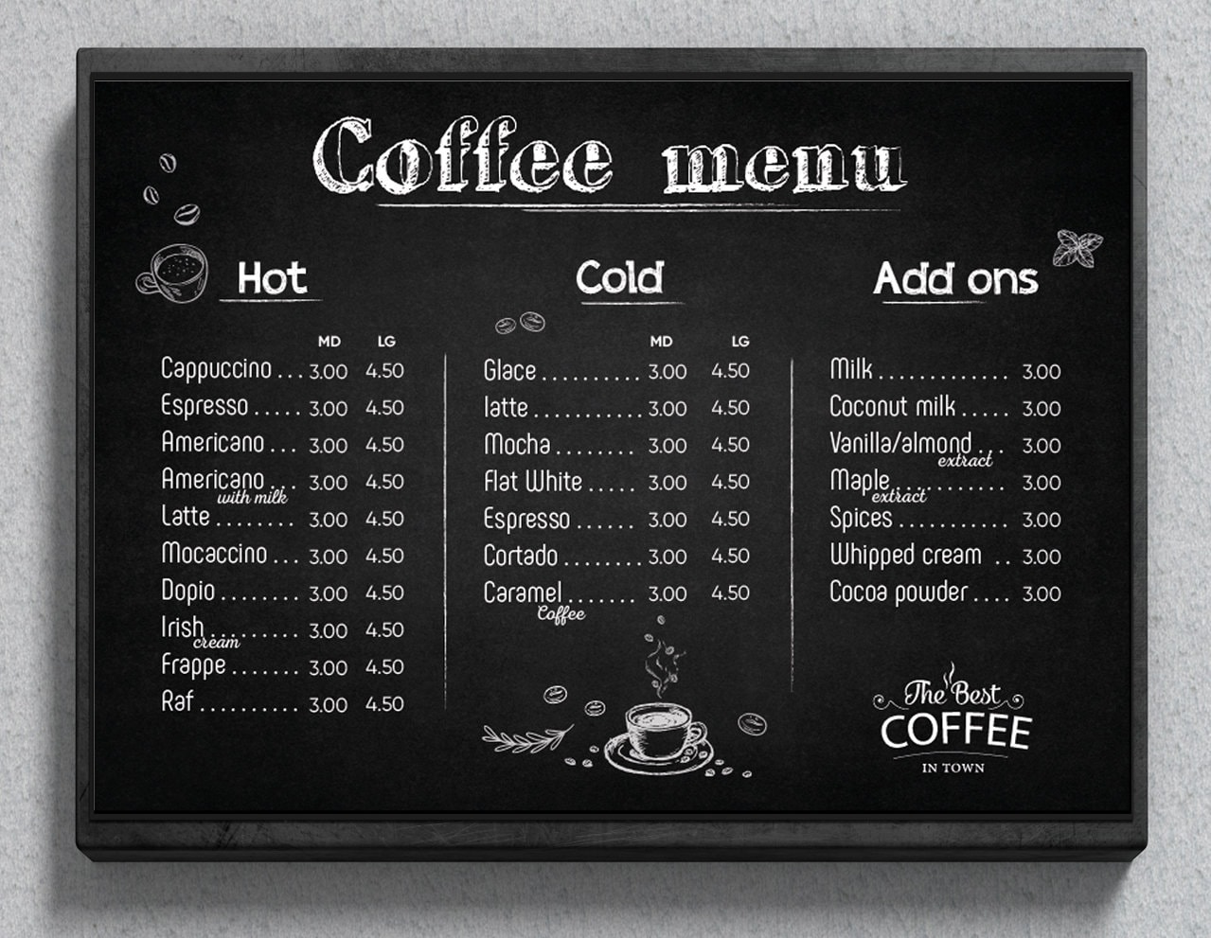

* Café

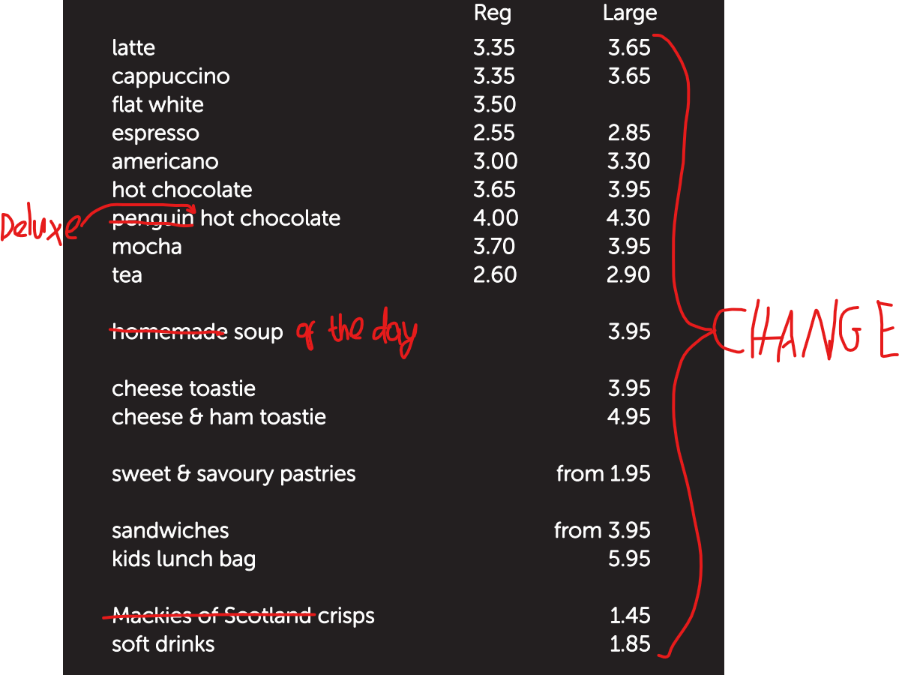

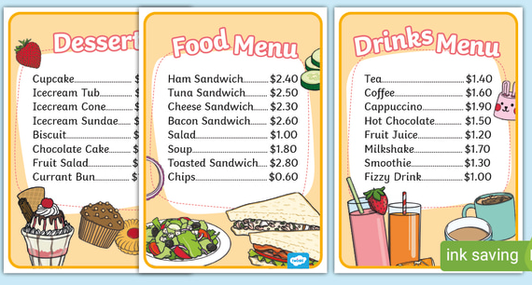

* Food Kiosks
  + Candy Floss + Sweets
  + Ice cream
  + Waffles
  + Pancakes
  + Sandwiches
  + Burger
  + Hotdogs
  + Loaded fries/chips
* Picnic Locations
  + A place where you can take a seat and relax while you enjoy your food and drink.
* Play area.
  + A place where children can play in a safe environment. Parents must ensure that their child is supervised for, safety purposes.
* Gift shop
  + Our gift shop contains everything ranging from trinkets such as keyrings to treats such as fudge. You can also purchase toys and games from the kids corner.